**Using environment variables**

Environment variables are useful for storing variables that you may want to change without modifying code.

Cody is going on vacation. While she would normally be the main person to receive messages, for a week it will be have to go to Jeff.

Let's tweak the Lambda function a bit to send a personalized SMS to Jeff!

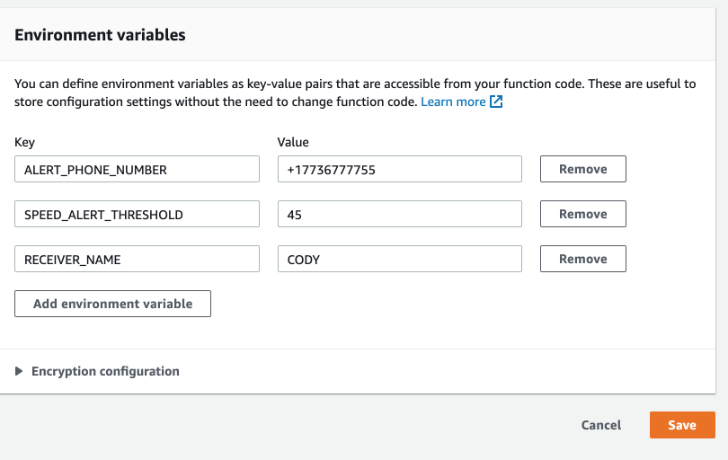

I have assigned Jeff's phone number and name to the relevant environment variables.

**Instructions**

**100 XP**

* Import the os module.
* Get the environment variables for PHONE_NUMBER and RECEIVER.
* Get the environment variable for DEPARTMENT, and if it's not set, fall back to 'Fleet Department'.

Code:

import os

# Get Environment variables, specify defaults

PHONE_NUMBER = os.environ.get("ALERT_PHONE_NUMBER", None)

RECEIVER = os.environ.get("RECEIVER_NAME", "Random Person")

DEPARTMENT = os.environ.get("DEPARTMENT", "Fleet Department")

# Construct message

message = """Hello {} from {}!

Here are the speeders:

{}

""".format(RECEIVER, DEPARTMENT, speeders.to_string())

# Send message

sns.publish(PhoneNumber = PHONE_NUMBER, Message = message)

<script.py> output:

Sent SMS to +12333325774:Hello Jeff from Fleet Department!

Here are the speeders:

VIN SPEED

0 5FTEX1MAXAK844295 88

1 3FTEX1G5XAK844393 95